HandsMenThreads: Elevating Men's Fashion with Salesforce

Abstract
HandsMen Threads, a dynamic organization in the fashion industry, is initiating a Salesforce Customer Relationship Management (CRM) implementation aimed at transforming its enterprise data management and customer engagement capabilities. The project centers on designing a robust, Salesforce-native data model that captures all critical business entities and their relationships, enabling a seamless and consistent flow of information across sales, operations, inventory, and customer service functions. By enforcing data integrity directly at the user interface layer through structured field types, validation rules, and governed input constraints, the solution seeks to ensure accurate, reliable, and analytically useful data for operational reporting and strategic decision-making.
Objective
The primary objective of this project is to design and implement a Salesforce-based solution for HandsMen Threads that centralizes business data, enforces data integrity at the user interface, and strengthens customer relationships across the organization. The initiative focuses on a robust data model and targeted automation for processes such as order confirmations, loyalty management, stock monitoring, and bulk order handling to enable reliable reporting, data-driven decision-making, and improved operational efficiency.
More specifically, the project pursues the following objectives:​
- Automate key post-order and inventory processes, including customer email confirmations, loyalty status updates, and low-stock alerts, to reduce manual effort and errors.​
- Ensure high data quality and integrity through a well-structured data model and strict validation rules enforced at the user interface.​
- Provide real-time, shared visibility into inventory levels, customer interactions, and sales performance to support timely, coordinated decision-making.​
- Strengthen collaboration among sales, inventory, and marketing teams by consolidating data and workflows within a unified Salesforce environment.​
- Enable scalable, personalized customer engagement via automated communications and a dynamic loyalty program driven by purchase behavior.​
- Demonstrate and apply core Salesforce skills, including data modelling, data quality management, Lightning App Builder, record-triggered flows, and synchronous/asynchronous Apex for complex and scheduled business logic.

TECHNOLOGY DESCRIPTION
Salesforce is a cloud-based Customer Relationship Management (CRM) platform that centralizes customer and business data across sales, service, marketing, and related functions. It provides integrated tools for contact management, analytics, workflow automation, and collaboration, enabling organizations to improve customer service, optimize campaigns, and increase sales performance. Within this project, Salesforce serves as the core platform for managing HandsMen Threads’ operational and customer data while automating key processes such as order handling, loyalty updates, and stock monitoring. The solution combines low-code configuration tools (e.g., Lightning App Builder and record-triggered flows) with programmatic extensions (Apex and asynchronous processing) to implement tailored, business-specific logic at scale.
Custom Objects
These custom objects serve as dedicated data repositories within Salesforce, specifically structured to capture and manage HandsMen Threads’ business-specific information.
- HandsMen Customer: Stores comprehensive customer information, including personal details, contact information, and the customer’s current loyalty status.
- HandsMen Product: Maintains the product catalogue, capturing attributes such as product name, description, price, and other key characteristics relevant to merchandising and sales.
- HandsMen Order: Records each customer order in detail, linking it to the corresponding HandsMen Customer and HandsMen Product records, and capturing order date, quantities, and total order value.
- Inventory: Tracks current stock levels for each HandsMen Product, supporting visibility into available quantities and enabling monitoring of low-stock situations.
- Marketing Campaign: Stores information about marketing initiatives and promotions, allowing the organization to track campaign details, target segments, and link outcomes to customer responses and orders.
Tabs
Tabs provide quick access to the key business areas configured in Salesforce for HandsMen Threads. Each core object has its own tab (such as HandsMen Customer, HandsMen Order, HandsMen Product, Inventory, and Marketing Campaign), allowing users to efficiently view, create, and manage records directly within the “HandsMen Threads” app.​
Custom App
A dedicated Lightning app named “HandsMen Threads” was configured as the main workspace for the team. It brings together all relevant tabs—Customer, Order, Product, Inventory, Campaign, and Reports—into a single interface, supporting an organized and streamlined workflow for daily operations.​
Profiles & Roles
Profiles and roles are used to control system access and data visibility in line with organizational responsibilities.​
- Profiles: Define what users can do in Salesforce, including which objects and fields they can access and how pages are presented; custom profiles such as a “HandsMen Sales Profile” are tailored to specific job functions.​
- Roles: Determine record-level visibility based on the company hierarchy, so a Sales Manager can view team-wide sales data while a Sales Representative primarily sees their own records.

Permission Sets
Permission sets are used to extend access beyond a user’s base profile so that specific roles can work with the objects they need without over-privileging other users. In this implementation, access is aligned with business responsibilities: Sales Managers are granted full access to customer and order records, Inventory Managers receive read and edit rights on inventory and product data, and the Marketing Team has read access to customer information while being able to edit marketing campaigns. This model provides fine-grained control over functionality while preserving a clear separation of duties.​
Validation Rules
Validation rules act as safeguards to ensure that records meet defined quality standards before they are saved in Salesforce. They are used to enforce correct formats, prevent logically inconsistent values (such as negative stock quantities), and ensure that required information is captured, thereby maintaining reliable data for reporting and automation.​
Email Templates and Alerts
Standardized email templates and automated alerts support consistent, event-driven communication with customers and internal users. In this solution, an HTML Order Confirmation email is sent when an order is placed, a text Low Stock Alert is triggered when Inventory__c.Stock_Quantity__c < 5, and an HTML Loyalty Program Email is sent when a customer qualifies for rewards.
Flows
Flows are our visual automation tools – they let us build complex business logic without writing a single line of code! Here are some key flows we built
Email Notification Flow: This one automatically sends an order confirmation email to the customer the moment a new order is placed.

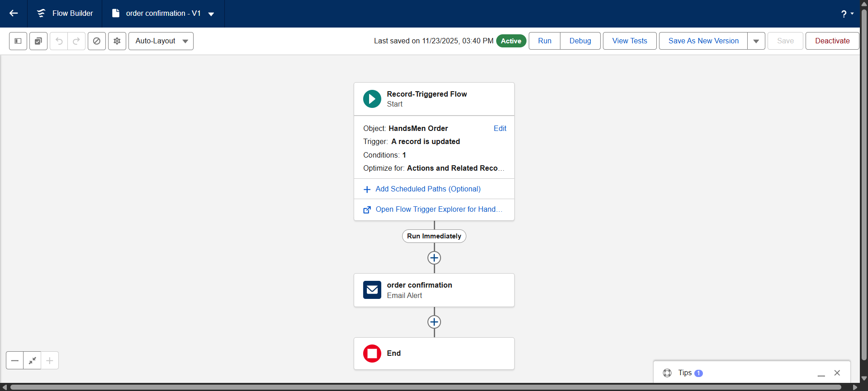

Stock Update Flow: When an order is created or changed, this flow automatically updates the product's available stock.
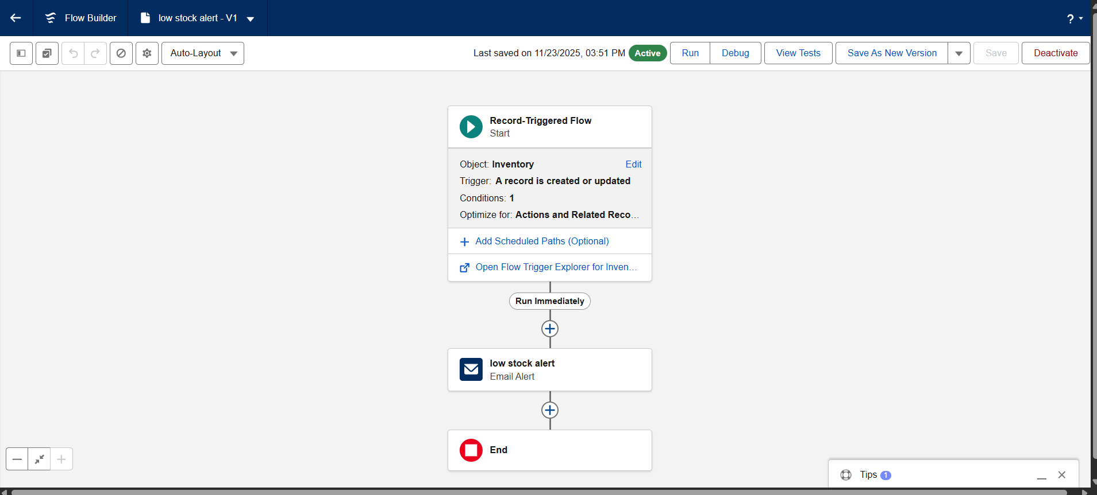

Scheduled Loyalty Update Flow: This flow runs every day (say, at midnight) to check and update customer loyalty statuses based on their total purchase amounts.
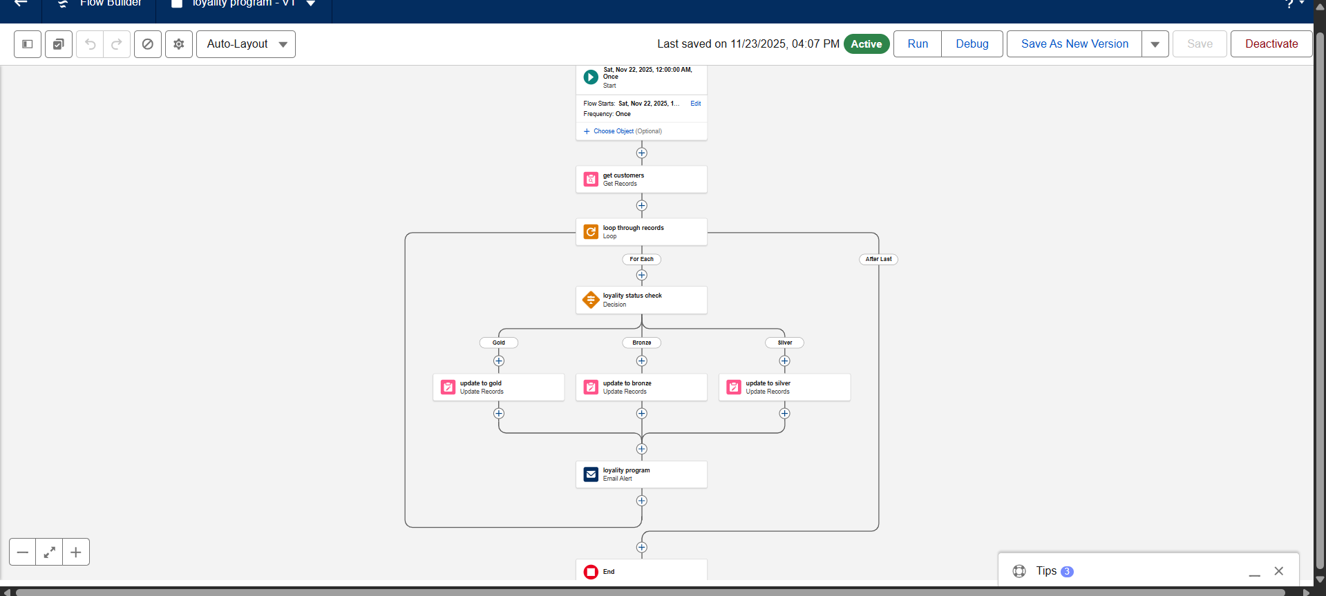

Apex
To support business-specific automation that goes beyond point-and-click configuration, the solution implements a set of focused Apex triggers.​
- Update Order Total (Object: Order__c) – Automatically recalculates and updates the Total_Amount__c field whenever an order record is saved, ensuring that order totals always reflect the current quantities and unit prices.​
- Stock Deduction (Object: Inventory__c) – Reduces the relevant inventory quantity when an order is placed, keeping stock levels synchronized with confirmed sales transactions.​
- Loyalty Status Update (Object: Customer__c) – Adjusts a customer’s loyalty status based on their cumulative purchase value, upgrading them when predefined thresholds in the loyalty program are met.

DETAILED PROJECT EXECUTION
Salesforce Developer Org Setup
A dedicated Salesforce Developer Edition org was provisioned via the Salesforce signup site and used as the primary environment for all configuration, development, and testing activities.
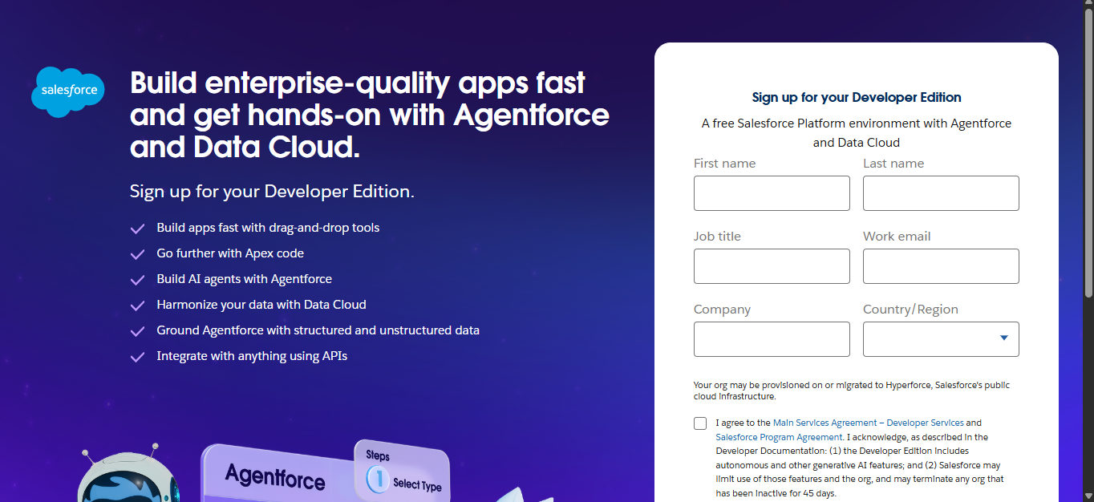

Custom Object Creation
The core Salesforce data model for HandsMen Threads was implemented by defining custom objects and associated fields to capture all essential information about customers, orders, products, inventory, and marketing campaigns.
- HandsMen Customer (Customer__c): For customer details (Name, Email, Phone, Address, Loyalty_Status__c).
- HandsMen Product (Product__c): For product information (Name, Description, Unit_Price__c, Stock__c).
- HandsMen Order (Order__c): For customer orders (Date, Quantity__c, Total_Amount__c, linked to Customer and Product).
- Inventory (Inventorys_c): Tracks available stock levels for each product, supporting inventory monitoring, replenishment decisions, and prevention of stockouts.
- Marketing Campaign (Marketing_Campaign__c): For promotional activities.

Custom Lightning App
A dedicated Lightning app called "HandsMen Threads" was configured to serve as the primary workspace for users. It brings together the key tabs HandsMen Customer, HandsMen Order, HandsMen Product, Inventory, Marketing Campaign, and Reports into a single, intuitive interface to support streamlined day-to-day operations.
Validation Rules
We implemented rules to ensure data quality and enforce business constraints. For example, product stock values are prevented from dropping below zero, and customer email entries must follow an approved email format before the record can be saved.
User Profiles & Roles
- Profiles: Cloned "Standard User" to create profiles like "HandsMen Sales Profile."
- Roles: Defined a hierarchy including "Sales Manager," "Inventory Manager," etc., controlling data visibility based on responsibilities.

User Creation
New user accounts were created and assigned to appropriate roles and profiles—for example, Niklaus Mikaelson for Sales and Kol Mikaelson for Inventory—to demonstrate differentiated access control and the system’s multi-user capabilities across business functions.
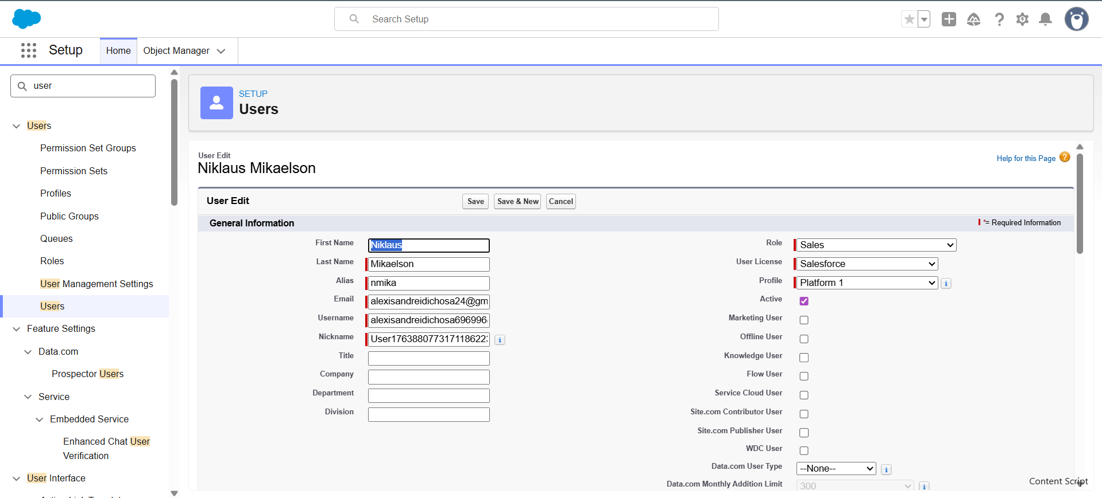
Email Templates
Custom email templates and alerts were configured for key events: an HTML Order Confirmation email is sent when an order is placed, a text Low Stock Alert is triggered when inventory drops below five units, and an HTML Loyalty Program Email is delivered when a customer becomes eligible for loyalty rewards.
Flow Implementations
a. Order Confirmation Email (Record‑Triggered)
Sends an order confirmation email to the customer whenever a new order is created.
b. Stock Alert Email (Record‑Triggered)
Sends an alert email when a product’s inventory falls below a defined stock threshold.
c. Loyalty Status Update (Scheduled Flow)
Runs on a daily schedule to evaluate customers’ total purchases and update their loyalty status when they qualify for a higher tier
Apex Triggers
- OrderTriggerHandler – Central handler class that encapsulates the business logic for order calculations and related stock updates.​
- OrderTrigger – Apex trigger on the order object that calls OrderTriggerHandler to automatically update order totals and adjust inventory when orders are created or modified.​
- Loyalty Status Trigger (CustomerLoyaltyUpdateTrigger) – Trigger on the customer object that refreshes a customer’s loyalty status in line with their cumulative purchase history.

SCREENSHOTS

Fig: Custom App for HandsMen Threads
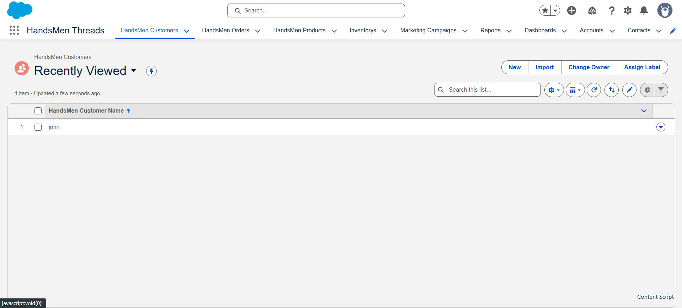

Fig: Customer Creation in HandsMen Threads
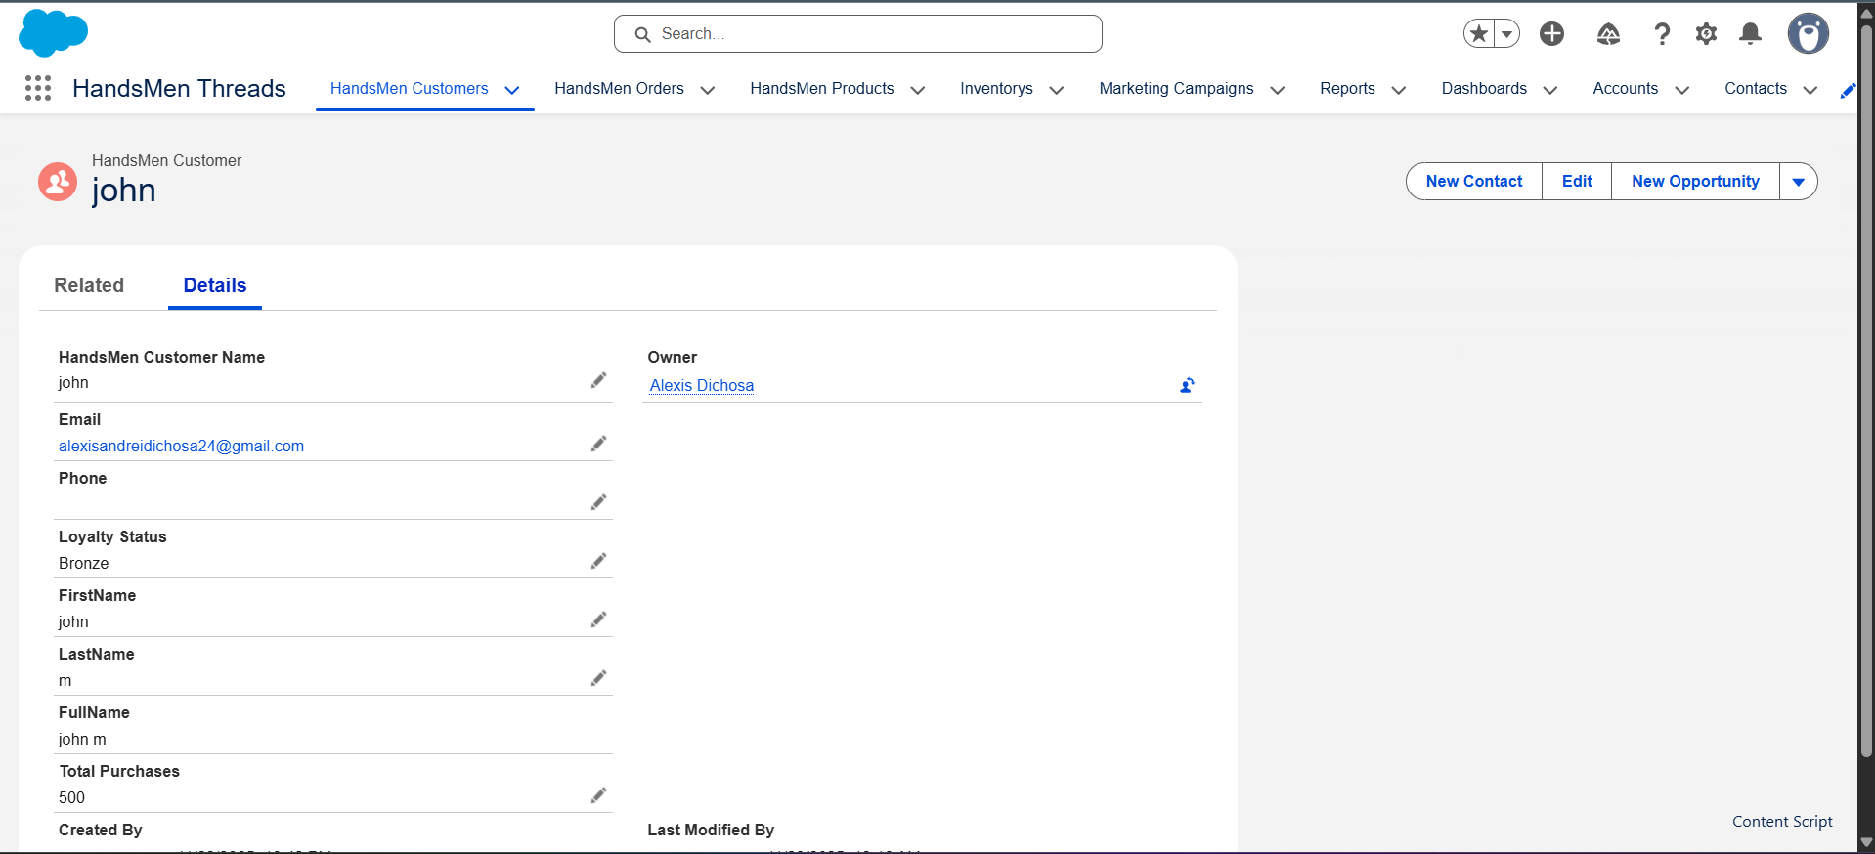

Fig: Product List View
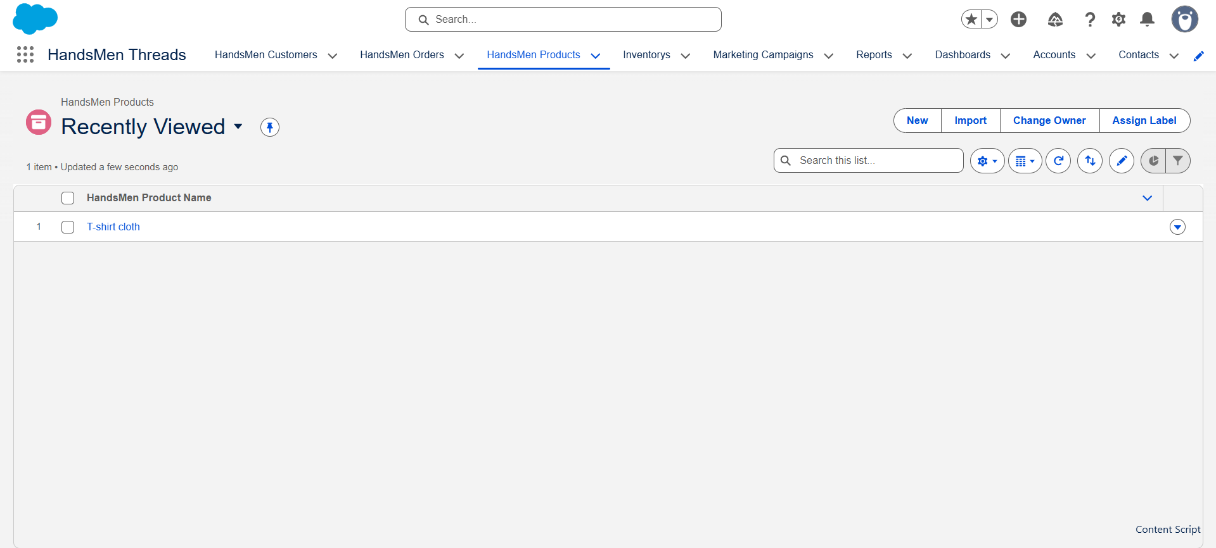

Fig: New Order Creation Page
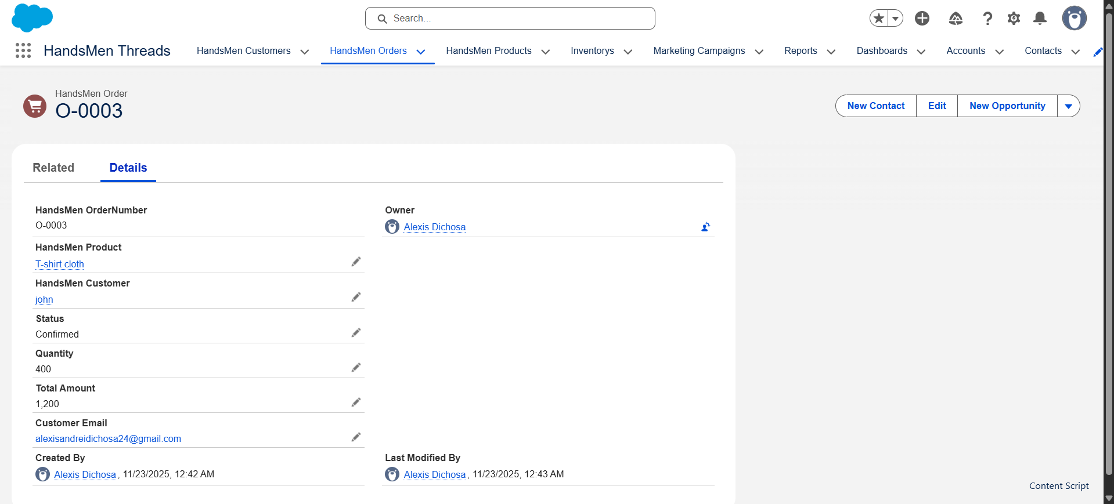

Fig: Order Confirmation

Fig: Order Confirmation Email Sent to Customer
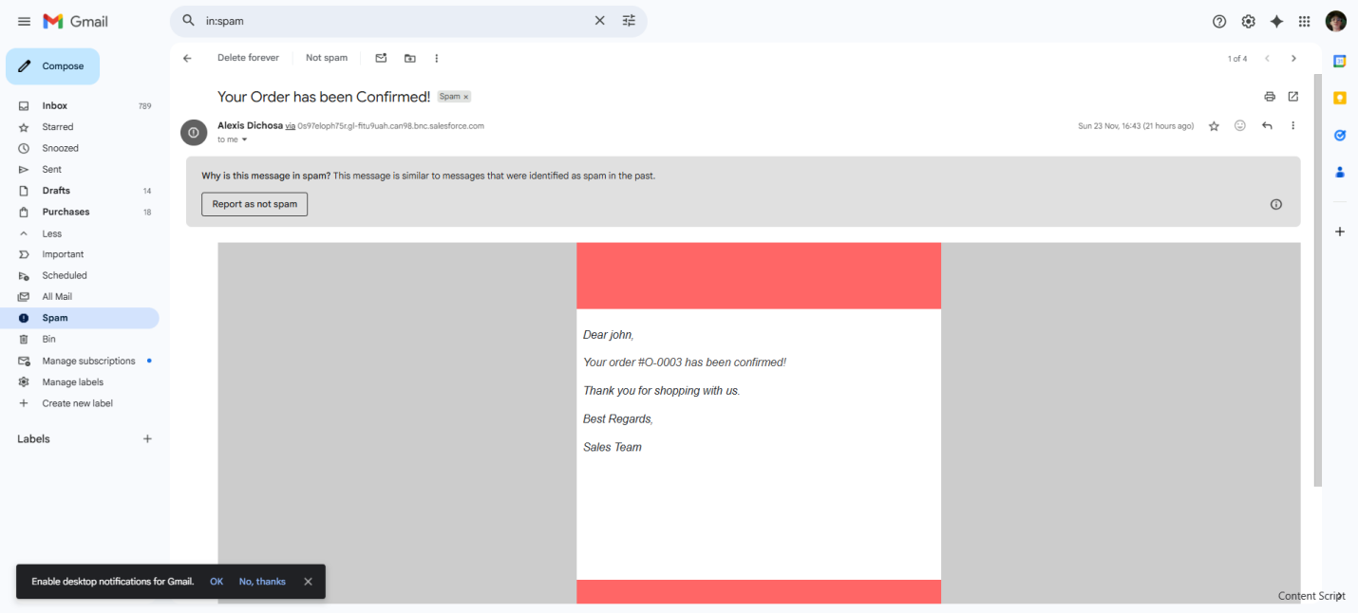

Fig: Inventory Creation
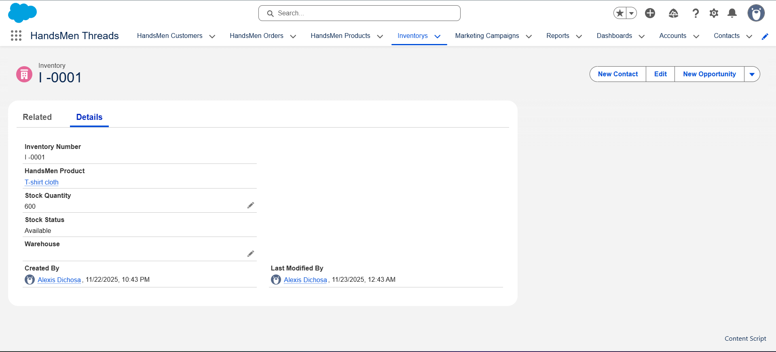

Fig: Low Stock Alert
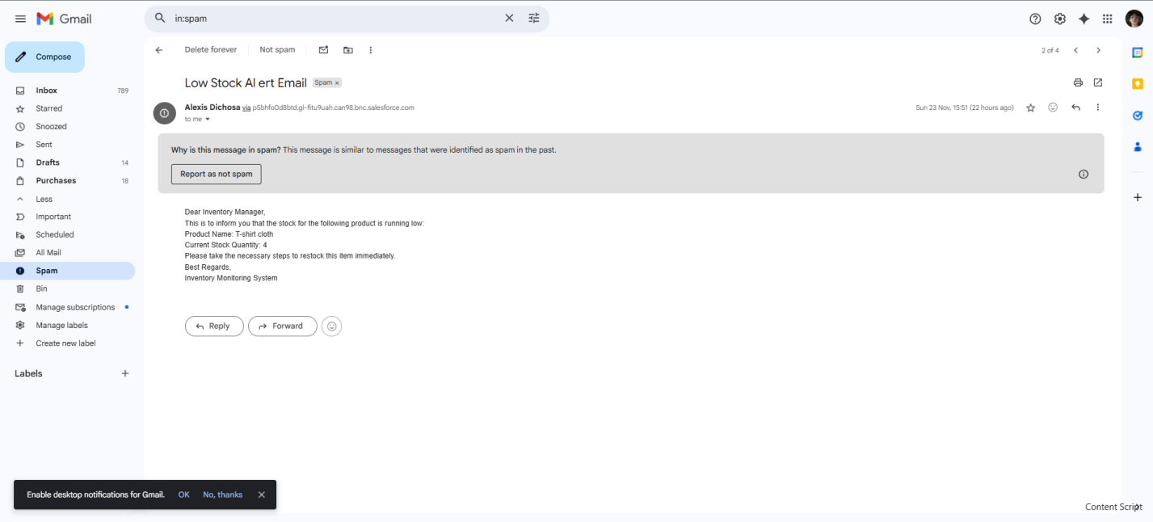

Fig: Customer Record Showing Updated Loyalty Status
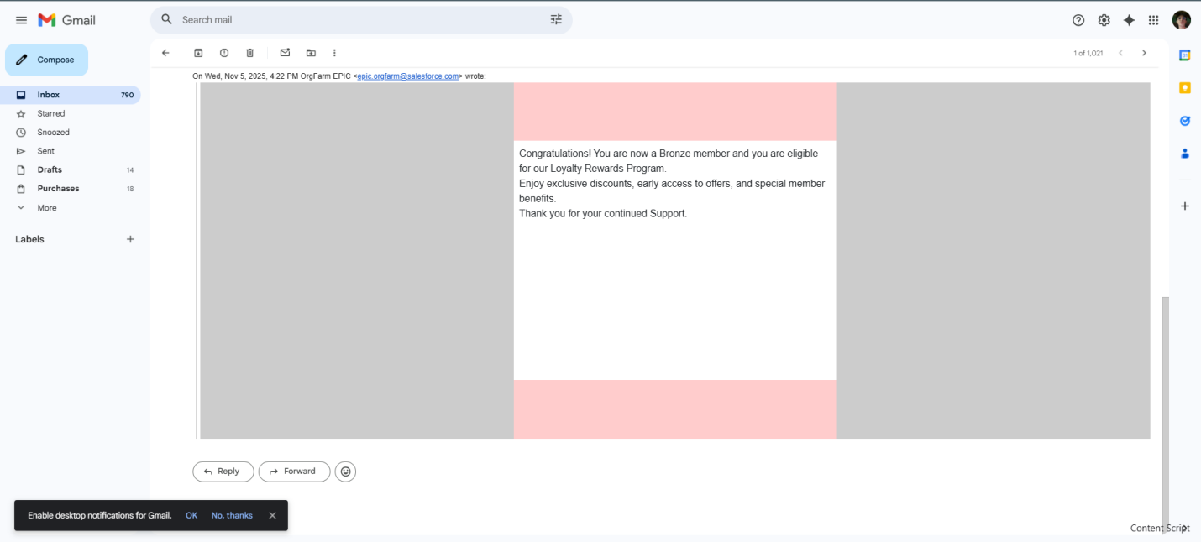

CONCLUSION
- The “HandsMen Threads – Elevating the Art of Sophistication in Men’s Fashion” project shows how a Salesforce-based CRM can act as the digital backbone of a premium menswear brand by unifying customer, order, product, inventory, and marketing data in a single platform. Through a tailored data model, record-triggered and scheduled flows, and targeted Apex logic, the solution automates order processing, inventory control, and loyalty management, significantly reducing manual effort and the risk of operational errors. Real-time visibility into sales performance, stock levels, and campaign outcomes provides decision-makers with actionable insights to refine merchandising and promotional strategies in line with the brand’s focus on sophistication and personalized service. Beyond fulfilling the internship requirements, the implementation demonstrates how low-code tools and pro-code extensions on Salesforce can be combined to create a scalable foundation for future growth, omnichannel expansion, and deeper customer engagement in the fashion retail sector.
FUTURE SCOPE
The Salesforce CRM for HandsMen Threads can be extended in several strategic directions to further elevate customer experience and operational efficiency in premium menswear retail.
  - Customer portal: Build a self-service portal where customers can log in to view past orders, track loyalty points, update their profile, and submit support requests, reinforcing a premium, personalized brand experience.​
  - Mobile app for staff: Develop a mobile app for store and operations teams so they can check inventory, place orders, and access customer profiles on phones or tablets, enabling more responsive in-store and back-office service.​
  - Advanced reports and dashboards: Design richer sales, inventory, and campaign performance dashboards to monitor best-selling products, slow movers, and high-value customers, supporting data-driven merchandising and marketing decisions.​
  - AI-powered product recommendations: Use Salesforce Einstein to surface “complete the look” and “customers who bought this also liked” suggestions across email, web, and potential portals, increasing average order value and cross-sell opportunities.​
  - Messaging integration: Connect WhatsApp, SMS, or similar channels to send real-time order updates, delivery notifications, loyalty milestones, and tailored promotions directly to customers’ phones.​
  - Unified customer profiles with Data Cloud: Consolidate data from web, store, and marketing interactions into a single 360° customer view, enabling more precise segmentation and highly targeted campaigns.​
  - AI stylist and service agents (Agentforce): Introduce AI agents that act as virtual stylists and support assistants, helping customers choose outfits, answering order queries, and resolving simple issues automatically.​
  - Omnichannel ecommerce integration: Integrate Salesforce with an online storefront so that catalog, pricing, inventory, and orders stay synchronized, delivering a seamless experience across physical and digital touchpoints.​
₊

